Of Mountains and Marshes

Focus Question
What are some of the differences between various plants found in the salt marsh and mountain habitats? Can students locate various plants, animals and physical features in the mountain and salt marsh habitats of the SC Aquarium?

Activity Synopsis
The students will explore the mountain and salt marsh habitats of the SC Aquarium in search of various plants. They will utilize a data sheet to classify various plants and other features as either “found in the mountains” or “found in the salt marsh.” The students will also observe other characteristics of the two habitats and how these features may affect the types of plants and animals that utilize the different areas.

Time Frame
Approximately 30 minutes

Student Key Terms
- mountain
- salt marsh
- cold
- hot
- wet
- salt water
- mud

salinity
- halophyte

Objectives
The learner will be able to:
- Locate various plants and other features in both the salt marsh and mountain habitats.
- Identify various characteristics of the salt marsh and mountain habitats that could impact the variety of plants and animals found in them.

First Grade Standards Addressed

Science Standards
IA4a, IIC1a, IIC1b

Background

Relevant Pages in:
Keener-Chavis, Paula and Leslie R. Sautter. 2002. Of Sand and Sea: Teachings from the Southeastern Shoreline. S.C. Sea Grant Consortium, Charleston, SC.

Key Points
Key Points will give you the main information you should know to teach the activity.

- There are various factors including temperature, salinity, soil type, rainfall amounts and wind conditions that can determine the types of plants and animals that inhabit an area.
- Plants and animals that inhabit mountain areas must be able to tolerate conditions including cold temperatures, rocky soils and wind.
- Plants and animals that inhabit the salt marsh must be able to tolerate conditions including high salinity, salt spray, high temperatures, desiccating winds and high levels of sunlight.

Detailed Information
Detailed information gives you more in-depth background to increase your own knowledge, in case you want to expand upon the activity or if students ask you more complicated questions.
The various habitats in South Carolina are characterized by a wide variety of weather and soil conditions. The mountains experience freezing temperatures during the winter months as well as the freezing precipitation that often accompanies these temperatures. Plants that live in the mountains must be able to survive under these harsh conditions. Examples of plants that are found frequently in mountain habitats are ferns, mosses, and mountain laurel. Since the mountain plants require cool, wet conditions, the scorching days of the Charleston summer would prove deadly to them. In order to simulate conditions similar to those in the mountains of SC in the aquarium’s mountain exhibit, the staff employs several modern technologies with varying degrees of success. The mountain exhibit has several machines that produce a fog or mist to keep the plants moist even in dry weather. The exhibit also employs a series of underground pipes carrying cold water that serve to cool the soil during the summer months. Finally, the exhibit is surrounded by a large windscreen to protect the plants from the gusty Charleston Harbor winds.
The salt marsh may experience temperatures from freezing (on rare winter occasions) to over 100 degrees F in the summer months. Salt marshes are tidally influenced which means that during each tidal cycle, plants within the tidal range will be inundated with salt water near high tide and may be high and dry for a period of time near low tide. Because of this, salt marsh plants have developed mechanisms to deal with salt water including thick, fleshy, succulent leaves and salt glands. Plants that can tolerate elevated salinity levels are called halophytes. Some examples are black needle rush (Juncus) and smooth cord grass (Spartina).
The plants and animals used in this activity are described briefly below.
“Little Brown Jug” (Hexastylis arifolium) This herbaceous (or non woody) plant can be identified by its heart shaped leaves and small flowers that are shaped somewhat like a jug. This plant ranges over much of the eastern portion of the US and is often found on the forest floor up to elevations of 3000 feet. They are most common in SC in dry to moist deciduous forests (Porcher and Rayner, 2001). The roots and stems of this plant have an odor similar to the ginger root that is often used in far eastern cooking. For more information on this plant, visit http://2bnthewild.com/plants/H109.htm.
Great Blue Heron (Ardea herodias) This large wading bird is found throughout the US in wetland areas. They feed primarily on fish and aquatic invertebrates and can often be seen feeding on the mudflats of salt marshes at low tide. They can grow to up to 38 inches in length and can have a wingspan of over 70 inches. They have a thick yellow bill and can usually be identified by the “S” shape of their neck during flight. For more information on the Great Blue Heron, visit http://www.mbr-pwrc.usgs.gov/id/framlst/i1940id.html.
Spanish Moss (Tillandsia usneoides) This gray colored plant can often be found hanging from the branches of live oak trees in tropical and near tropical climates such as that of coastal South Carolina. It is present from the SE US south to Argentina and Chile. Spanish moss is not a true moss and is actually unrelated to the order of mosses including sphagnum. Spanish moss, and its relative the pineapple, belongs to the family of plants known as bromeliads. Spanish moss will grow only on trees, but it is not a parasite and therefore does not draw its nutrients from the tree. For more information on Spanish moss, visit http://www.co.beaufort.sc.us/bftlib/spanish.htm.
Haircap Moss (Polytrichum spp.) These common mosses are found throughout the world in areas where moisture levels are high including swamps, woodlands and bogs. They cannot tolerate saline conditions, however, and therefore are not present in salt marshes. These mosses have been used historically for a variety of purposes including medicinal uses, broom making and bedding. For more information on these and other mosses, visit http://www.borealforest.org/lichens/lichen10.htm.
Maidenhair Fern (Adiantum pedatum) Te maidenhair fern is common in eastern North America. They are often found in moist soils in forests. They may also be found in seepages associated with cliffs (Porcher and Rayner, 2001). The leaves may have been used as a hair rinse by Native Americans, thus the plant’s common name. The fronds of this fern are horseshoe shaped and the plants are typically 12-18 inches high. These plants can withstand the cooler temperatures often found in the mountains and foothills of our state.
The Palmetto Tree (Sabal palmetto) This familiar tree is the state tree of South Carolina. It is a branchless tree that can reach heights of over 65 feet. The Palmetto as it is commonly known, is an evergreen tree with a mass of leaves located at its top. The palmetto is a coastal plant found from North Carolina south to Florida. It does not occur naturally more than 75 miles from the coast. The palmetto is a wind-adapted species. The leaves offer little wind resistance and the stems are flexible to allow the tree to bend during high wind events such as hurricanes and tropical storms.
Black Needle Rush (Juncus roemerianus) This marsh species is easily identified by its long, pointed leaves that are often blackish gray in color. It is often found in salt marshes in large stands. The black needle rush grows from rhizomes. Marshes dominated by black needle rush are the primary nesting and feeding habitat for birds such as the clapper rail and the seaside sparrow. It also provides excellent cover for birds and other marsh dwelling species such as rabbits and raccoons. It can tolerate a wide range of salinities. Black needle rush reproduces both sexually and asexually. When seeds are dispersed, new stands can be created. The seeds are light dependent and therefore, seedlings are restricted to barren sandy areas where sufficient light can reach the seed even if it is covered. Salinities over 15 ppt inhibit the successful germination of seeds. For more info on black needle rush, visit http://www.fs.fed.us/database/feis/plants/graminoid/junroe/.

Procedures
Materials
- Data sheets (attached)
- Clipboards and pencils for each student
Procedure
- Before your trip to the aquarium, have the students brainstorm words and phrases to describe the mountains and the salt marsh. If the students have difficulty, prompting them with words such as cold, foggy, rainy, salty, rocky, and muddy may be useful in getting them started. Following the brainstorming, show the mountain and salt marsh portions of the SC Aquarium video that is available in your school’s media center. Tell the students to look for evidence in the video to support or deny the items that they came up with while brainstorming.
- Upon arrival at the Aquarium, explain to the students that they will be looking for various plants, animals and other features in two different areas of the aquarium: The Mountains and the Salt Marsh.
- Ask the students “What do plants and animals need to survive?” Ask them “Are the air, water, soil and space the same in the mountains and in the salt marsh?” Explain that because the habitats are different, the plants and animals must be able to cope with the different conditions to survive. Plants that are in the mountains may not be able to survive in the salt marsh and vice versa.
- Pass out data sheets to each student. Explain that on the left side of the paper, there are 8 items. Some are plants, some are animals and some are physical features. Explain to the students that they will be looking for the items in the mountains and the salt marsh. If they find the item in the mountains, they will draw a picture of a mountain in the square to the right of the item. If they find the item in the Marsh, they will draw a picture of some marsh grass in the square to the right of the item. If the item is found in both the salt marsh and the mountains, they should draw both pictures in the square.
- When you enter the mountain exhibit, ask the students what they notice about the area. Some of the characteristics they nay notice are: cold, wet, rocky, foggy, etc. Ask them “Are these some of the things we came up with in the classroom to describe the mountains?”
- Let the students search for their items as they enjoy the rest of the exhibit.
- As the students are searching for and locating the items, ask them to describe the plant. Have them look at the leaves, stems etc and briefly describe them to you.
- When you enter the salt marsh exhibit, ask the students what they notice about the area. Some of the characteristics they may notice are, muddy, windy, salty, etc. Ask the students “How is the water different in the SALT-marsh than in the mountains?” Explain that even the plants that do not live in the water have to be able to live around salt water. Because of wind-blown salt spray, even plants that live in areas that are not tidally influenced must be able to accommodate higher salinity.
- Let the students search for their items as they enjoy the rest of the exhibit.
- As the students are searching for and locating the items, ask them to describe the plant. Have them look at the leaves, stems etc and briefly describe them to you.
- After the students have completed the data sheets (perhaps after returning to the classroom), lead a discussion of the differences the students noted between the plants, animals and physical features of the mountains and the salt marsh. Remind the students that because of the different weather and soil conditions, the plants in each of the areas will be different.

Assessment
Choose a plant that is found in either the salt marsh or in mountain habitat. Find a picture of the plant. Public domain pictures can often be found on the web using a search engine such as Google (www.google.com). Another useful site is the NOAA photo database, which is located at www.photolib.noaa.gov. Show the students the picture of the plant and give them several characteristics of the plant. Have the students draw a picture of the plant in the habitat in which they think it lives. Have the students explain why they think the plant would live in a particular habitat.
Mastery/Nonmastery: The student draws the plant in the correct habitat and can describe why the plant would be located in that habitat.



Members of the COASTeam Aquatic Workshops development team include: Katrina Bryan, Jennifer Jolly Clair, Stacia Fletcher, Kevin Kurtz, Carmelina Livingston, and Stephen Schabel.
Plant, Animal or Feature | Habitat (Mountain or Salt Marsh)
Wild Ginger
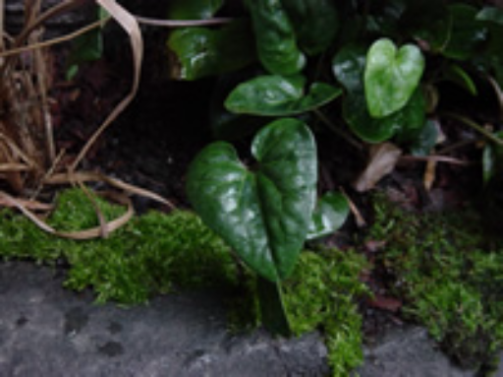
Great Blue Heron
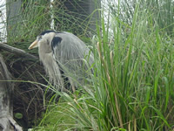
Spanish Moss
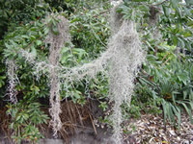
Fern
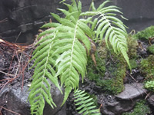

Plant, Animal or Feature | Habitat (Mountain or Salt Marsh)
Palmetto
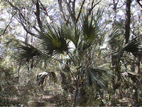
Waterfall
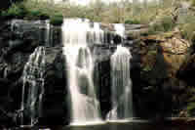
Moss
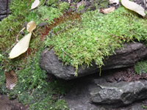
Black Needle Rush


