Animal Family Reunion

Focus Question
How can you tell if animals are related to each other?

Activity Synopsis
Students will be given photographs of ten different animals from the Mountain region of South Carolina and will group them together based on the shared characteristics they observe. Students will then be given the characteristics used by scientists to classify animals as fish, amphibians, reptiles, birds or mammals, and compare the classification system they developed to the scientific classification system.

Time Frame
One class period

Student Key Terms
- amphibian
- bird
- classification
- cold-blooded
- fish
- mammal
- reptile
- warm-blooded
- ectothermic
- endothermic
- taxonomy

Objectives
The learner will be able to:
- observe characteristics that different animals have in common.
- group animals according to shared characteristics.
- classify animals as fish, amphibians, reptiles, birds or mammals based on observation.

Fourth Grade Standards Addressed

Science Standards
IA1a; IA2a; IIA3c

Background

Key Points
Key Points will give you the main information you should know to teach the activity.

- Scientists classify organisms according to shared characteristics. They observe the features of an organism (such as the number of legs it has, the presence of hair or scales, etc.) that are shared with them by other species and break them up into categories that go from general to specific.
- In the taxonomic system, fish, amphibians, reptiles, birds and mammals are all classified in the phylum Chordata and kingdom Animalia, but are in groups distinct from each other.
- Fish
There is a great deal of diversity among the animals we call fish, but they all share certain things in common. All fish:
  - live in water
  - have fins
  - breathe through gills
  - ectothermic.

- Amphibians
Amphibians include the frogs, toads and salamanders. Amphibians:
  - have smooth or bumpy skin
  - are dependent on water for reproduction
  - can breathe with lungs or gills depending on the species, but all can breathe through their skin
  - ectothermic.

- Reptiles
Reptiles include lizards, snakes, turtles and crocodilians (alligators, crocodiles and a couple others). They are characterized by:
  - having tough, dry, scaly skin
  - breathing with lungs
  - having eggs with a leathery eggshell that does not have to be laid in water to survive (though some reptiles do not lay eggs and instead have live births)
  - being ectothermic (cold-blooded).

- Birds
Birds have some fairly obvious common characteristics:
  - feathers
  - beaks
  - wings
  - lay eggs.
as well as some not so obvious characteristics, such as:
  - remarkably lightweight bones
  - being endothermic (warm-blooded).

- Mammals
Mammals are the group of vertebrates that includes humans, river otters and dolphins. The characteristics of mammals are they:
  - are warm-blooded,
  - have hair
  - breathe air with lungs
  - give live births
  - produce milk

Detailed Information
Detailed Information gives more in-depth background to increase your own knowledge, in case you want to expand upon the activity or you are asked detailed questions by students.

Biologists estimate there may be anywhere from 8 to 450 million different types of organisms alive on earth today, with the general consensus being around 30 million. To date, scientists have discovered and named over 1.7 million different organisms. Since Aristotle's time, scientists have attempted to identify and classify these organisms. The science of classification is known as taxonomy.

Modern taxonomy classifies organisms according to shared characteristics. Scientists observe the features of organisms (such as the number of legs it has, the presence of hair or scales, etc.) and break them up into categories that go from general to specific depending on how many of these characteristics they have in common. These include the categories we all learned in school (kingdom, phylum, class, order, family, genus, species) in pneumonic phrases such as "King Phillip Came Over For Great Spaghetti" or "Kings Play Chess On Fancy Glass Stools". As more is learned about the natural world and how complex it is, new categories have been added (domains, subphylums, superphylums, etc.). These categories and what organisms are classified in them is constantly being refuted and altered. Because of this, to know the ins and outs of taxonomy one must continuously be learning, unlearning and relearning. Even so, taxonomy can be helpful to know the general characteristics of certain groups of plants and animals.

All animals are classified in the kingdom Animalia. There is still a lot of debate as to what an all-encompassing definition of "animal" should be, but generally it is a multi-cellular organism that consumes living or dead organic material to acquire the energy it needs to survive, or, more simply, a large organism that eats other things to survive. Traditionally, animals have been divided into vertebrates (animals with a backbone) and invertebrates (animals without a backbone). This shows a little bias on our part (being vertebrates ourselves), as there is only one phylum that vertebrates are contained in while there are over thirty phyla of invertebrates, and invertebrates make up the vast majority of animals on the planet. Still it is a useful distinction for thinking about the animals we see most commonly.

Fish, amphibians, reptiles, birds and mammals are all vertebrates. Vertebrates are actually a subphylum of the phylum, Chordata. Chordates are characterized by having a spinal cord at some point in their development. These tend to be the animals with which we are most familiar. Our familiarity is based on the fact that: a) we are one of them and b) they are the largest and most visible animals. They are by no means the most abundant (beetles alone make up one-fifth of the world's known animals), but they are unique in the world of nature and they have been very successful (just look out the window to see how successful at least one of their species has become. Hint: you are one of them).

In the taxonomic system, fish, amphibians, reptiles, birds and mammals are all classes in the phylum Chordata and kingdom Animalia. Species are grouped into these classes because of characteristics they share with each other.

Fish

There is a great deal of diversity among the animals we call fish, but they all share certain things in common. All fish:
- live in water
- have fins
- are ectothermic
- and breathe through gills.
Beyond that, though, there are many differences.

The two major groupings of fish are the bony fish and the cartilaginous fish. The bony fish contain the fish that we typically think of as fish, such as bass, trout, snappers and tuna. Bony fish have skeletons made out of bone (thus the name). They only have one gill opening that is protected by a hard flap known as an operculum. Many bony fish also have an organ known as a swim bladder. A swim bladder allows a bony fish to stay buoyant in different depths by filling with or releasing gas. Bony fish are found throughout the world's aquatic habitats.

Cartilaginous fish include the sharks, skates and rays. These fish have skeletons made out of cartilage (thus the name), the same stuff that makes up our ears and nose. Because of this you will not find a fossilized shark skeleton, as it will decay too quickly. Cartilaginous fish are also characterized by having 5 to 7 gill slits and by not having a swim bladder like a bony fish does. A cartilaginous fish has an oil-filled liver that keeps it somewhat buoyant, but if it stops swimming, it will sink to the bottom. Cartilaginous fish are found primarily in marine habitats.

Amphibians

Amphibians include the frogs, toads and salamanders. Amphibians:
- have smooth or bumpy skin
- are dependent on water for reproduction
- are ecothermic
- and can breathe with lungs or gills depending on the species, but all can breathe through their skin.

Amphibians tend to have smooth or bumpy skin. They do not have scales, feathers or hair. Though some amphibians spend almost their entire adult lives on land, all amphibians are dependent on water during reproduction. Amphibians lay their eggs in water because the developing larvae inside the egg does not have a large yolk sac and is dependent on absorbing the air and water it needs from the water. Amphibians also spend their larval stage in water (tadpoles (or pollywogs, depending on where you are from) are the larval stage of frogs and toads). Some amphibians spend their adult life underwater, but some spend it on land and some move back and forth between both. Some amphibians have lungs or gills or both or neither for breathing, but all amphibians can breathe through their skin.

Reptiles

Reptiles include lizards, snakes, turtles and crocodilians (alligators, crocodiles and a couple others). They are characterized by:
- having tough, dry, scaly skin
- breathing with lungs
- having eggs with a leathery eggshell that does not have to be laid in water to survive (though some reptiles do not lay eggs and instead have live births)
- and being ectothermic (cold-blooded).

Ectothermic means they cannot control their body temperature internally. Their body temperature is generally the same as their environment. Because of this, reptiles are often seen basking in the sun to warm up and are most common in the tropics, though some species have been found in the Arctic Circle.

Birds

Birds have some fairly obvious common characteristics:
- feathers,
- beaks
- eggs
- and wings,
as well as some not so obvious characteristics, such as:
- remarkably lightweight bones
- and being endothermic (warm-blooded).

Feathers give birds two advantages: a means to stay warm and the ability to fly. Beaks come in a variety of sizes and shapes and, depending on the species of bird, can be used for everything from picking up tiny seeds to tearing pieces of meat off a buffalo carcass. Wings have given most birds the ability to fly, an advantage that allows them to more easily avoid predators, to cover more territory when looking for food or mates and, for some species, to avoid the cold, barren winter of the north by heading south. Lightweight bones also aid birds in flying by reducing the amount of weight they have to carry. Birds are endothermic (warm-blooded), meaning they control their body temperature internally and can survive in a wider variety of habitats than reptiles. Birds can be found just about everywhere on earth, including the polar icecaps and the most isolated oceanic islands.

Mammals

Mammals are the group of vertebrates that includes humans, river otters and dolphins. The characteristics of mammals are they:
- are warm-blooded,
- have hair
- breathe air with lungs
- give live births
- and produce milk that they feed to their newborn young.

Since whales are mammals, you can remember these characteristics by thinking of the phrase WHALE (Warm-blooded, Hair, Air-breathers, Live births, Eat milk). One of the remarkable characteristics of mammals is the size of their brain, massive in comparison to fish, amphibians and reptiles. Because of the size of their brains, mammals (such as dolphins, pigs, wolves, and humans) are the most intelligent organisms on earth. Mammals are found on all continents in the world, as well as the polar ice caps and the ocean.

Procedures

Materials
- 10 photographs of individual animals that includes 2 fish, 2 amphibians, 2 reptiles, 2 birds and 2 mammals. Suggested animals for the Mountain region of South Carolina:
  - Fish: Brook trout, Mottled Sculpin, Rainbow Trout
  - Amphibians: Spotted salamander (Ambystoma maculatum), hellbender, Fowler's toad, green salamander and American toad.
  - Reptiles: Eastern box turtle, snapping turtle (Chelydra serpentina), northern water snake and copperheadtimber rattlesnake.
  - Birds: downy woodpecker, ruffed grouse, belted kingfisher, spotted sandpiper, black throated blue warbler, wood thrush, Louisiana waterthrush and indigo bunting.
  - Mammals: Black bear, river otter, eastern pipistrelle (a bat) and eastern chipmunk

Procedure
1. Ask students, if they were walking with their family, how would a stranger be able to tell they were related? (Answer: they probably all look very similar). Tell them that scientists do the same thing to determine what animals are related to each other. They observe the characteristics the animals have in common, and classify them into groups with similar characteristics.

2. Break the students into small groups of about four students. Give each group the collection of animal photographs in random order (a good source of animal photographs is www.enature.com). Animals from the Mountain region of South Carolina that could be used are:
  - Fish: Brook trout, Mottled Sculpin, Rainbow Trout
  - Amphibians: Spotted salamander (Ambystoma maculatum), hellbender, Fowler's toad, green salamander and American toad.
  - Reptiles: Eastern box turtle, snapping turtle (Chelydra serpentina), northern water snake and copperheadtimber rattlesnake.
  - Birds: downy woodpecker, ruffed grouse, belted kingfisher, spotted sandpiper, black throated blue warbler, wood thrush, Louisiana waterthrush and indigo bunting.
  - Mammals: Black bear, river otter, eastern pipistrelle (a bat) and eastern chipmunk

Ask each student group to observe the animals and then to classify them into groups according to the characteristics they have in common. Have the students record the members of each of their groups. After they have had time to do this, have them explain to the class why they grouped the animals the way they did.

3. Go over the characteristics of fish, amphibians, reptiles, birds and mammals with the students (characteristics are listed in the background information). Have students classify their animal photographs according to these characteristics. How do these groupings match up to the groupings they came up with on their own? Discuss with students. Have students brainstorm other animals that would be classified as fish, amphibians, reptiles, birds and mammals. Have the students record the members of each of these major groups.

Assessment

Give students the attached assessment sheet. Have them group up the invertebrates on side one according to shared characteristics. Have them classify the animals on side 2 as fish, amphibians, reptiles, birds or mammals.

Rubric (Out of 13 points)
Match blue crab to spider crab (both are arthropods) 1 point
Match moon jelly to box jelly (both are cnidarians) 1 point
Match sea star to sea urchin (both are echinoderms) 1 point
Label alligator as reptile 1 point
Label kingfisher as bird 1 point
Label salamander as amphibian 1 point
Label bullfrog as amphibian 1 point
Label blenny as fish 1 point
Label fox as mammal 1 point
Label mouse as mammal 1 point
Label green sea turtle as reptile 1 point
Label great blue heron as bird 1 point
Label tiger shark as fish 1 point



Members of the COASTeam Aquatic Workshops development team include: Katrina Bryan, Jennifer Jolly Clair, Stacia Fletcher, Kevin Kurtz, Carmelina Livingston, and Stephen Schabel.

Animal Family Reunion
Assessment

(from COASTeam Aquatic Workshops: the Mountains (grade 4))

Directions: Draw a line between each pair of animals you think are closely related.

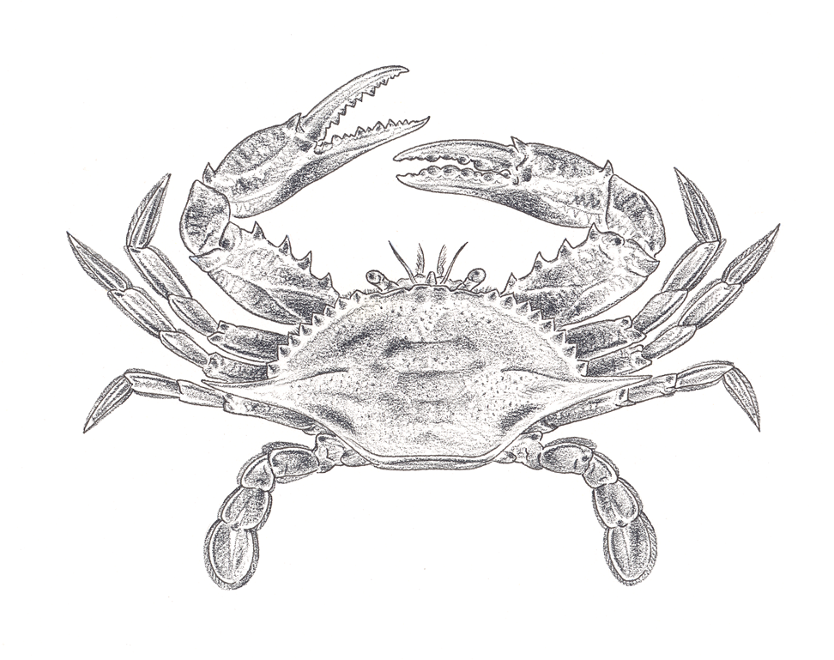
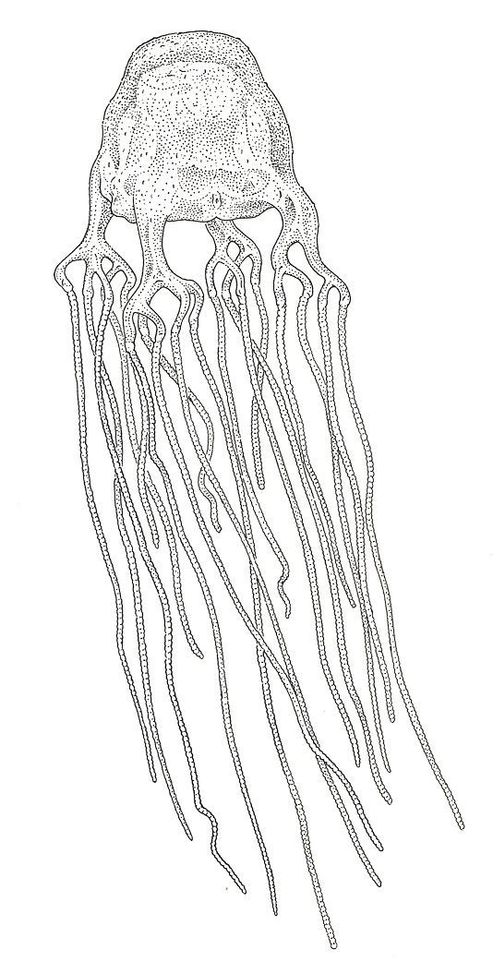

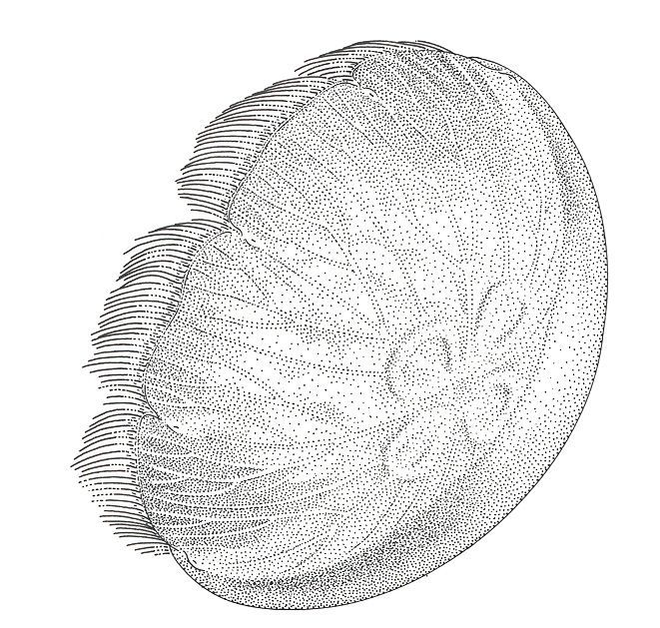

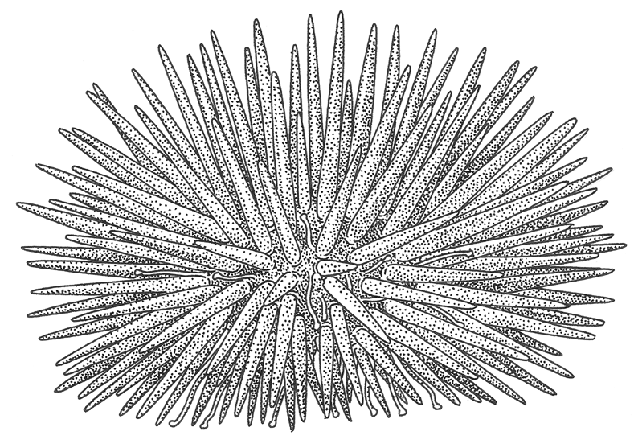

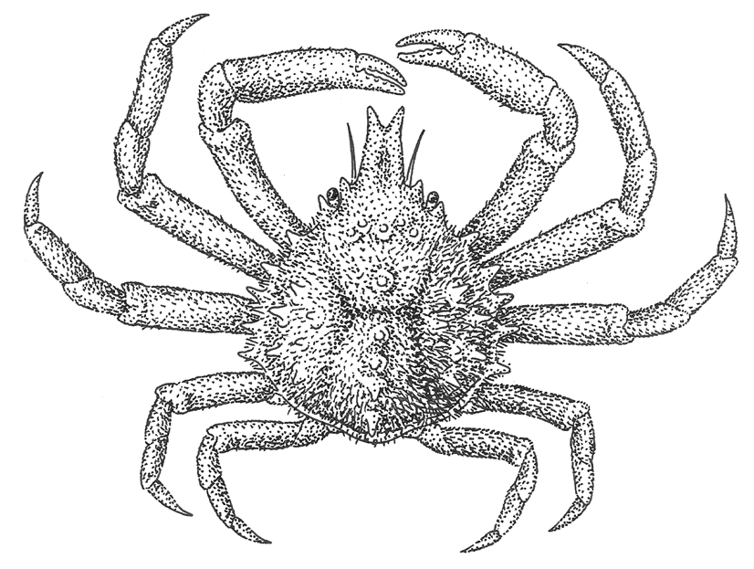

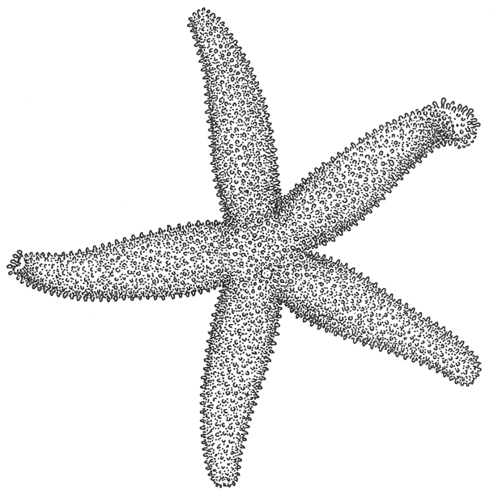

Illustrations by Val Kells
Directions: Label each of these animals as a fish, amphibian, reptile, bird or mammal based on the characteristics you observe.
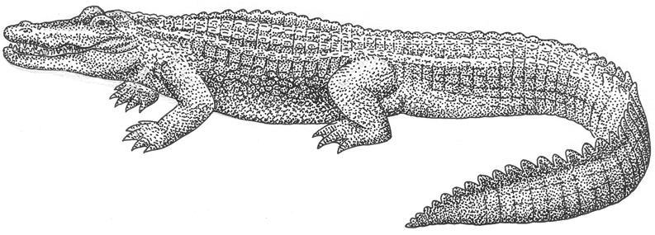
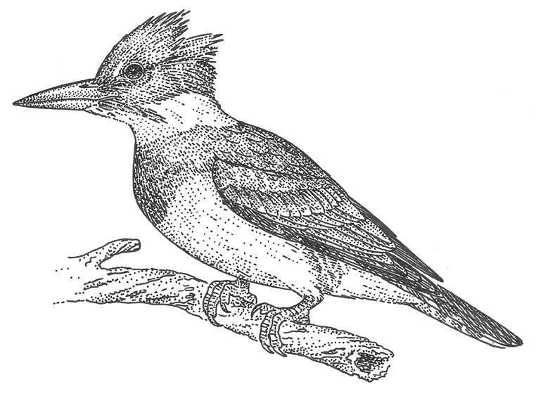
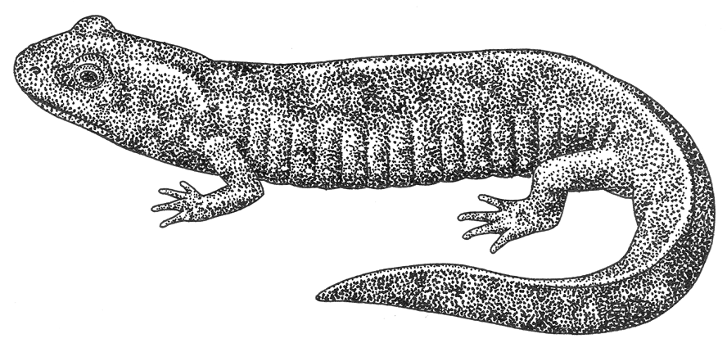
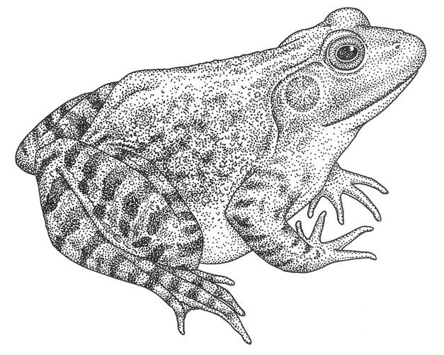
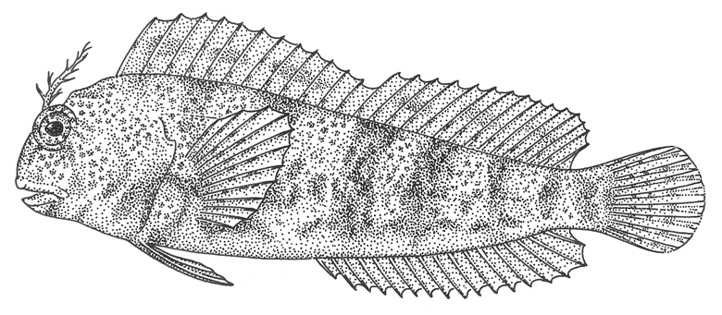
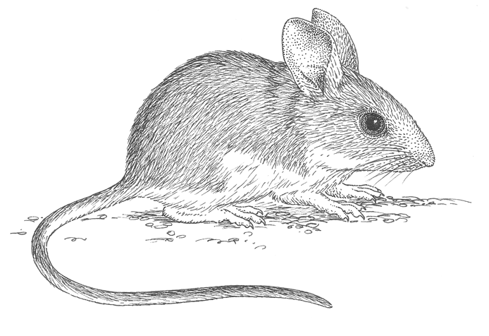
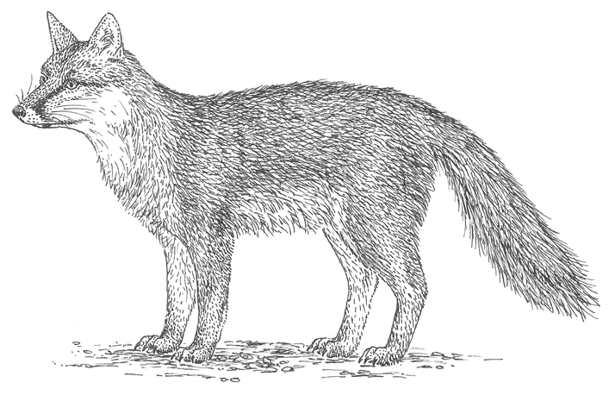
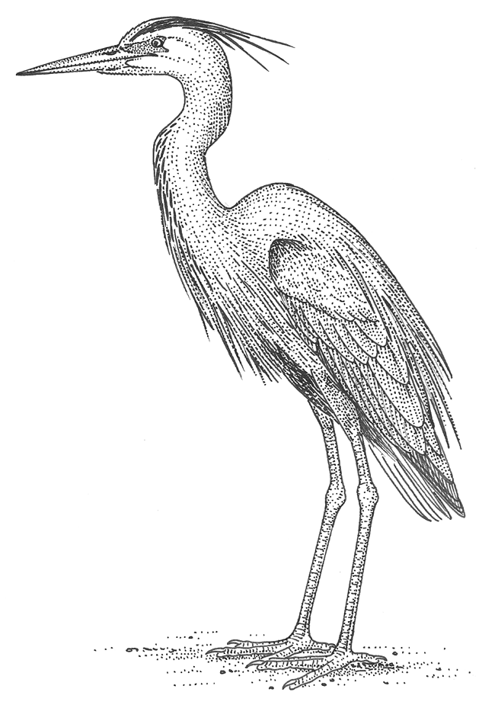
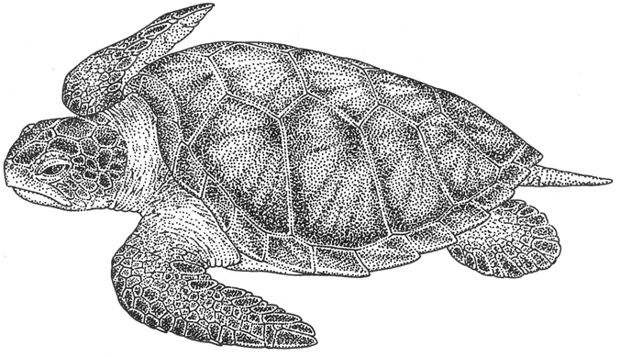
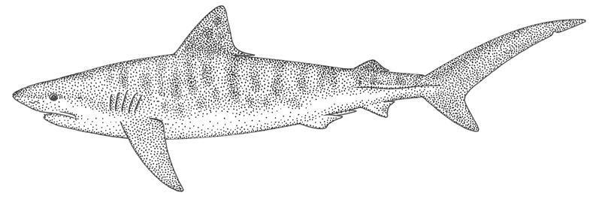
Illustrations by Val Kells

