Quakes and Plates

Dr. Leslie Sautter, Department of Geology, College of Charleston, SC
(reprinted with permission from TASA Graphic Arts, Inc.)

Focus Question
How do plate movements cause earthquakes? Where are the plate boundaries of the world?

Activity Synopsis
By comparing epicenter locations of shallow focus earthquakes with seafloor features and mountain chains, students will be able to approximate more than 80% of the world’s plate boundaries.

Time Frame
One hour

Student Key Terms
- epicenter
- focus
- plate

Objectives
The learner will be able to:
- Examine geographic patterns of shallow focus earthquakes by examining their epicenter distribution
- Identify associations between earthquakes and seafloor features
- Make inferences as to what the earthquake distribution means

Fifth Grade Standards Addressed
Science Standards
IIIA1e,f,h,i,k; IIIA2a,b

Background

Relevant pages in Of Sand and Sea (2000) by Paula Keener-Chavis and Leslie R. Sautter: pp. 7-16.

Key Points
Key Points will give you the main information you should know to teach the activity.
- The occurrence of earthquakes and volcanic eruptions along the edges of lithospheric plates is evidence that plates are in continual motion.
- Movement and friction along the plate boundaries frequently cause large amounts of energy to be released in the form of earthquakes.
- Because of the intense friction that results from the sliding motion of one plate past another, transform boundaries also have high occurrences of earthquakes.

Detailed Information
Detailed Information gives more in-depth background to increase your own knowledge, in case you want to expand upon the activity or you are asked detailed questions by students.

Excerpt from Of Sand and Sea:
The occurrence of earthquakes and volcanic eruptions along the edges of lithospheric plates is evidence that plates are in continual motion. Volcanoes are very common along these plate boundaries where molten, or melted, rock makes its way to the surface through cracks and faults. Movement and friction along the plate boundaries frequently cause large amounts of energy to be released in the form of earthquakes. Scientists are able to measure the minute movements of plates with very sensitive instruments, and have shown that plates move very slowly around the earth. In fact, most plates are presently moving at a rate of 1 to 4 centimeters (0.4 to 1.6 inches) per year, yet some exceed 10 centimeters (3.9 inches) in a year. Compare these rates to the rate of your fingernail’s growth, which is approximately 2 centimeters (0.8 inches) per year!

Because ridges are segmented on the curved earth, there are regions between the ridge segments where the motion is in opposite directions, and the edges of the plates are sliding past each other, rather than away from each other. This is actually another type of plate boundary, referred to as a transform boundary. Because of the intense friction that results from the sliding motion of one plate past another, transform boundaries also have high occurrences of earthquakes.

Intense frictional forces prevent the Pacific Plate from gliding easily past the North American Plate. Instead the plates are temporarily locked in position until the forces of movement overcome the frictional forces, resulting in an enormous release of locked-up energy: a California earthquake. Sunny California has the great misfortune of being situation astride the transform plate boundary, known as the San Andreas Fault.

Not all volcanoes and earthquakes are associated with plate boundaries. The Hawaiian Island chain of seamounts is located near the center of the Pacific Plate, without a spreading ridge or a convergent trench in sight! The Hawaiian volcanoes have been formed as the Pacific Plate has moved across an area known as a “hot spot”. A hot spot is where a huge chamber of melted rock is located deep within a mantle, providing a tremendous source of molten material to the earth’s surface. Scientists are still uncertain why hot spots occur, but the Hawaiian Island chain provides an excellent and active study site.

As the Pacific Plate passes over the hot spot a volcano is “born” directly above and is active for several million years. With time and movement of the plate, the volcano is carried far enough past the hot spot location to cause its dormancy and extinction. As it moves away from its position above the hot spot, the volcanic island cools and contracts, eventually sink below the ocean waves. The result is a chain of volcanoes where increasingly older and smaller (from contraction) volcanoes can be found with increasing distance from the hot spot that created them.

Procedures

Materials
- overhead transparency photocopy of Figure 1
- photocopy (on paper) of Figure 2 - Physiographic map of the Seafloor *
- photocopy (on paper) of Figure 3 – Plate Tectonic Map of the Earth
- large color map of the seafloor* (optional)
- 4 different color highlighter marker pens
- tape
- colored pencils – 8 to 12 colors

*To order color copies of the Physiographic Map of the Seafloor from TASA Graphics, Inc., visit www.tasagraphicsarts.com, call (800) 293-2725 or (505) 758-5535, or mail your order to:
TASA Graphic Arts, Inc.
1337 Gusdorf Road, Suite O
Taos, NM 87571-6298

Procedure
Student Instructions:
- Tape the overhead transparency of shallow focus earthquake epicenters to the Physiographic Map of the Ocean Floor. Use the longitude marks to align the transparency properly.

- Examine the Pacific Ocean. Compare the epicenter concentrations with seafloor features. When you observe a strong association between earthquakes and a certain type of seafloor feature, highlight that type of feature on the map with a color marker. Every time that particular association occurs, use the same color to mark the feature. If you identify other types of seafloor features that have a high concentration of earthquakes, mark them each in a distinctive color.

- Continue marking the map in other regions. Identify continental features with earthquakes and assign a color to them as well. Remember that you should be marking on the map only those seafloor or continental features that are directly under the earthquake epicenters.

- Make a key to indicate the type of seafloor or continental feature represented by each color.

- When you are done, remove the earthquake transparency. Find the eastern end of the Aleutian Islands of Alaska. Using a pencil, begin drawing a line that connects the different colored lines on your map. Head west first and see how far you can travel (in any direction) before you run out of colored lines. Do the same operation wherever you see connected chains of colored lines.

- Compare your map to a map of the earth’s lithospheric plates. Label and color the major plates on your map.

QUESTIONS

- What types of seafloor features are associated with a lot of shallow earthquake activity?

- What types of continental features are associated with earthquakes?

- What do earthquakes indicate is occurring at plate boundaries?

- Why do you think there are so few earthquakes within a plate?

- How do you think scientists decided the locations of plate boundaries?

- At which type of seafloor feature do you find the most earthquakes?

- Summarize your discoveries by discussing the associations between earthquakes, ridges, trenches, fracture zones, and mountain chains, and their connection to plates.

Assessment

Use the students’ transparencies to assess their understanding of the relationship between plates and the locations of earthquakes. Were the earthquakes and seafloor features marked correctly? Did the student’s transparency match a map of the earth’s lithospheric plates? Did the students create a correct key for their drawing?



COASTeam Aquatic Workshop Curriculum Development Team: Katrina Bryan, Jennifer Jolly Clair, Stacia Fletcher, Kevin Kurtz, Carmelina Livingston, Leslie Sautter, and Stephen Schabel

Written by Dr. Leslie Sautter and revised with permission by TASA Graphic Arts, Inc.

Figure 1: Distribution of Shallow Focus Earthquake Epicenters
Reprinted with permission from Tasa Graphic Arts, Inc.

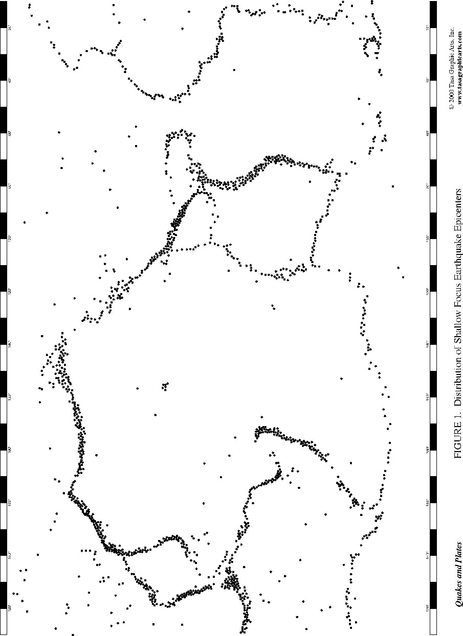

Figure 2: Physiographic Map of the Seafloor
Reprinted with permission from TASA Graphic Arts, Inc.

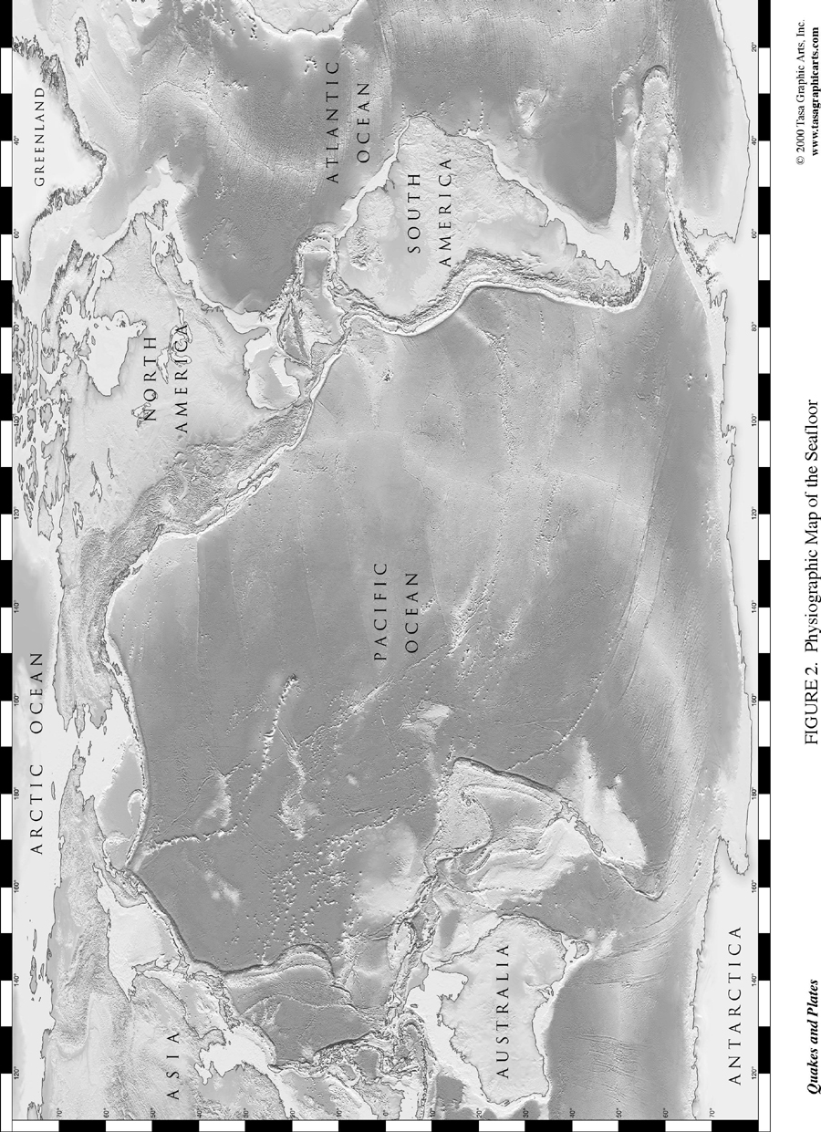

Figure 3: Plate Tectonic Map of the Earth

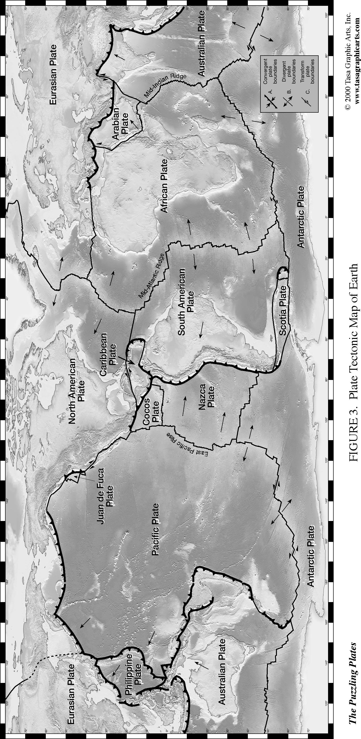Reprinted with permission from Tasa Graphic Arts, Inc.

