The Tantalizing Touch Tank

Focus Question
How can we use our sense to describe the contents of the touch tank?

Activity Synopsis
The teacher will lead the students in a touch tank sensory scavenger hunt.

Time Frame
20-30 minutes

Student Key Terms
- senses
- describe
- hard
- soft
- rough
- smooth
- spiny
- squishy
- wet
- bumpy
- prickly
- slimy
- sharp
- dull
- scratchy
- heavy
- light
- invertebrate
- Chordate

Objectives
The learner will be able to:
- Investigate the touch tank using his senses,
- Communicate about the touch tank using sensory descriptors.

Kindergarten Standards Addressed

Science Standards
IA1a, IA2a, IA4a, IB1a, IIA3b, IIA3c

Background

Relevant pages in:
Keener-Chavis, Paula and Leslie R. Sautter. 2002. Of Sand and Sea: Teachings from the Southeastern Shoreline. S.C. Sea Grant Consortium, Charleston, SC, pp. 40-47.

Key Points
Key Points will give you the main information you should know to teach the activity.

- The Sea Squirt is the only member of the Phylum Chordata in the touch tank. All other organisms are invertebrates!
- Each of the organisms in the touch tank has characteristics that make it well adapted to a particular habitat. We can describe these adaptations by using sensory descriptors. For example, the hard, knobby shell of the knobbed whelk provides protection for the mollusk inside.

Detailed Information
Detailed Information gives more in-depth background to increase your own knowledge, in case you want to expand upon the activity or you are asked detailed questions by students.

Slipper Lobster
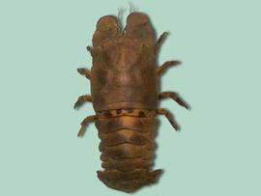
Slipper lobsters have a flattened body with shovel-like antennae and small claws. The eyes are in sockets within the head. The flattened body allows the slipper lobster to cling closely to rock walls. Their coloration makes them difficult to see during the day. They come out at night to forage for snails, oysters, and dead animal matter. The slipper lobster has a hard exoskeleton that encases the organism like armor.

Sea Whip
A sea whip is brightly colored colonial animal made up of many smaller organisms that resemble small anemones. The colonies are long, narrow, finger-like formations. The smaller organisms capture food for the entire colony with specialized stinging cells. Sea whips are classified as Cnidarians, a group that also includes hydroids, jellyfish, anemones, and corals.
For more information on the sea whip, visit http://www.sms.si.edu/IRLSpec/Leptog_virgul.htm.

Red-Beard Sponge
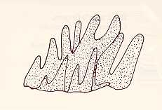
The red-beard sponge is recognizable by its bright red color. The organism has finger-like projections in colonies that can grow to be 20 cm high and 30 cm wide. Sponges feed by filtering microorganisms from the water. A red-beard sponge attaches itself to a hard substrate, such as on rocks or large shells, and remains in that spot for its entire life.

Sea squirts

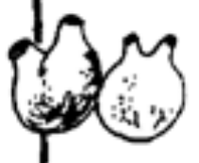
Sea squirts, or tunicates, are rubbery blobs that tend to squirt out watery when they are removed from their home. Sea squirts actually belong to the phylum Chordata, just like humans! That is because tunicates have gill slits, a supporting notochord (or backbone) and a spinal chord during the larval stage. Within approximately 24 hours, the tadpole-like tunicate larva will settle and attach itself to a hard substrate. At that time, the tunicate undergoes a transformation and becomes the form we recognize as a sea squirt! Sea squirts have two openings called siphons. Water moves into the incurrent siphon, is filtered through the pharynx where food particles are trapped, passes through the gill clefts where oxygen is removed, and then proceeds to exit through the excurrent siphon. Sharks, skates and other bottom-dwelling fish eat sea squirts.

Spider Crab
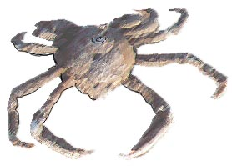
The spider crab is a slow moving scavenger that is not particularly aggressive and is completely harmless to humans. The spider crab’s main defense against predators is camouflage. The carapace has hook-like hairs that hold algae and other small debris on the crab. The grayish-yellow to brown carapace is round and spiny.

Sea Star

Sea stars are echinoderms, a group of organisms with spiny skin covering their skeletons. Other echinoderms include sea cucumbers, sea urchins, and sand dollars. A sea star’s skeleton is made of plates that move like flexible joints.
The sea star is capable of regenerating body parts. Each arm contains a small eyespot on the tip that is sensitive to light. Hundreds of tube feet line the arms. The tubes enable the sea star to move. The sea star draws in water and channels it into canals that run throughout its body. By changing the water pressure within the body, the sea star and can move the tube feet. The tube feet are also important in respiration and collecting food. The suction of the tube feet helps the sea star to pry open bivalves.

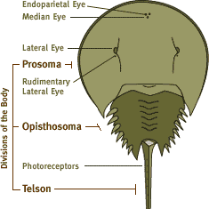
Horseshoe Crab
The shell of the horseshoe crab is shaped roughly like a horseshoe (hence the name) and is divided into two sections. The front section (the prosoma) is fairly smooth although there are several bumps in the location of the crab’s compound eyes. The horseshoe crab has five pairs of legs on the ventral surface of the prosoma. The back section of the horseshoe crab (the opisthosoma) is recognizable by its pointed edge. The ventral surface of this section houses the “book gills” of the crab, which function similarly to the gills of a fish. They also help propel the crab while it is swimming. The horseshoe crab’s pointed tail does not function as a weapon. It is used to steer during locomotion as well as to flip the crab over if it is turned onto its back. The female horseshoe crab’s shell may reach a length of 60 cm (24 inches) but the male is usually smaller. Fore more information on the horseshoe crab, visit www.horseshoecrab.net.

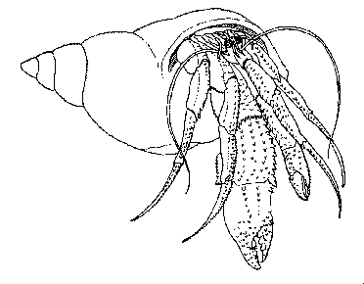
The Hermit Crab
The hermit crab, unlike most crabs, lacks a protective shell over the hind-most portion of its body (the abdomen). In order to protect this portion of its body, the hermit crab inserts it into the shell of a gastropod (whelk, etc.). Therefore, the shells of hermit crabs will vary according to the size and variety of the shell the crab is utilizing. Typically, there are three visible pairs of appendages on a hermit crab. These vary from the claw like pinchers to the pointed walking appendages. All of the appendages have a somewhat bumpy surface with varied coloration. Often, colonies of algae, polyps, sponges, anemones and other small marine organisms grow on the shells utilized by the hermit crabs. These can lend a somewhat bumpy or slimy character to the shell. When hermit crabs can no longer comfortably fit into the shell in which they reside, they “move out” and search for a larger shell. If the shell is still occupied by the gastropod, the crab picks out the original occupant and takes over the shell.
For more information on hermit crabs, visit http://www.xs4all.nl/~pal/hermit.htm.

Knobbed Whelk
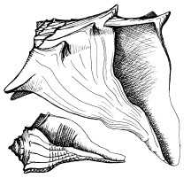
The knobbed whelk is an example of a gastropod. The adult shell may be 240 mm in length. Large pointed spines around the “shoulder” of the shell characterize the shell. The knobbed whelk is a “right sided” whelk which means that when held wide side up, the opening is on the right side The outer color of the shell is grayish white or tan often with streaks of darker color. The interior of the shell is smooth and can be any color in the range of yellow to dark red. The body of the whelk is pinkish in color and may be characterized as squishy. A hard shell plate called the operculum, which can cover the shell opening in the event of attack, by a predator, protects the body.
For more information on the knobbed whelk as well as other varieties of whelk, visit www.arches.uga.edu/~amylyne/GSC/whelk.html.

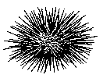
Pointed spines cover Sea Urchin the sea urchin. The spines of many sea urchins are harmless to humans, although some are very sharp and may contain venom. The spines have several functions: protection, locomotion and collection of food. Underneath the spines of a sea urchin is the hard shell of the creature known as the test. The test is made up of plates that may resemble the sections of an orange. Sea urchins may be a variety of colors.
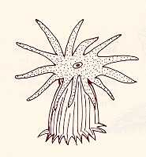
For more information on sea urchins, visit http://seaurchin.org/Sea-Grant-Urchins.html or http://www.starfish.ch/reef/echinoderms.html.

Sea Anemones Sea anemones are well-recognized members of the Phylum Cnidaria, the animal grouping known as the stinging animals. The anemones are representative of the polyp form of the cnidarians (as opposed to the medusa form such as the jellyfish and the man of war). They live attached to the sea floor or to other organisms such as whelks and abandoned gastropod shells. A ring of tentacles surrounds the mouth of the anemone. Sea anemones can move in a limited capacity if the need to relocate arises. Se anemones have a great capacity for regeneration of body parts and can even reproduce asexually through a process known as fission (splitting in half).
For more information on sea anemones, visit http://waquarium.mic.hawaii.edu/MLP/search/anemone.html.

Procedures

Materials
- Optional – magnifying glasses
- Optional – field guides to identify touch tank organisms. (Please note: there is an Aquarium volunteer stationed at the touch tank to assist visitors.)

Procedure
- Explain to the students that the organisms in the touch tank will not hurt people; however, they should not pick up organisms in the wild.
- Tell the students to place their hands into the water and describe how it feels. Prompt the students to locate various objects and organisms in the touch tank using “I spy something…” Have the students locate something hard, soft, rough, smooth, spiny, squishy, wet, bumpy, prickly, slimy, sharp, dull, scratchy, heavy, light.
- Does the way the organisms feel remind the students of anything they touch in their homes or at school?

Assessment

Give the students a variety of craft materials; including sandpaper, felt, construction paper, toothpicks, aluminum foil, etc. Have each student re-create his or her favorite touch tank critter and explain his creation using sensory descriptors.
Mastery/Nonmastery: Student uses correct sensory descriptors to discuss the organism and chooses appropriate craft materials to create the organism. Example, if the student describes an organism as “rough”, he should use sandpaper and not felt to create his art.



Members of the COASTeam Aquatic Workshops development team include: Katrina Bryan, Jennifer Jolly Clair, Stacia Fletcher, Kevin Kurtz, Carmelina Livingston, and Stephen Schabel

